**Advanced Geometry**

**Mrs. Vrazel**

**2023-2024**

**Welcome**!

This course is a comprehensive look at the study of geometric concepts including the basic elements of geometry, proofs, parallel and perpendicular lines, the coordinate plane, triangles, quadrilaterals, polygons, circles, trigonometry, congruence and similarity, surface area, volume and transformations. Emphasis will be placed on developing critical thinking skills as they relate to logical reasoning and argument.

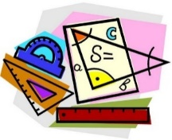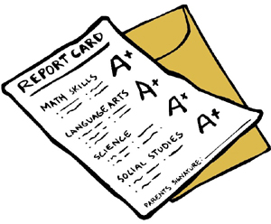

**Retakes/Late Work/Tutorials**

We don’t always succeed the first time we try something, but with a positive attitude, a bit more practice, and some help from others, we can learn from our failures! This is why students who earn a failing grade are allowed the opportunity to correct their mistake.

* **Retakes**
  + Students who make below a 70 on a test will be allowed to do corrections to bring that grade up to a 70. Students must complete the test review before the original test. Corrections must be done during tutorials within two weeks of the original test.
* **Late work**
  + Late work is not encouraged, but it will be accepted up to 3 days after the due date with a grade deduction of 25 points.
* **Tutorials**
  + Tuesday and Thursday until 3:15
  + Availability is subject to change. I will do my best to announce changes.

**Classroom Expectations**

Be on-time, on-task, and prepared to learn everyday

Keep all **personal** electronics put away

Don’t interrupt others’ right to learn or my right to teach

Be responsible for your own learning

Respect the teacher, The classroom, and the other students

**Needed Materials**

* Folder with Brads
* Spiral Notebook
* Pencils
* Fully charged device

**Contact Info**

Email: jenny.vrazel@sfisd.org

Phone: (409) 927-3100

**Remind**

Text @advgeovra to 81010 to get reminders about Advanced Geometry.

**Grade Categories:**

**Major** (Tests, Projects, Notebook) – 40%

**Minor** (Quizzes, Activities, Homework, Other) – 60%

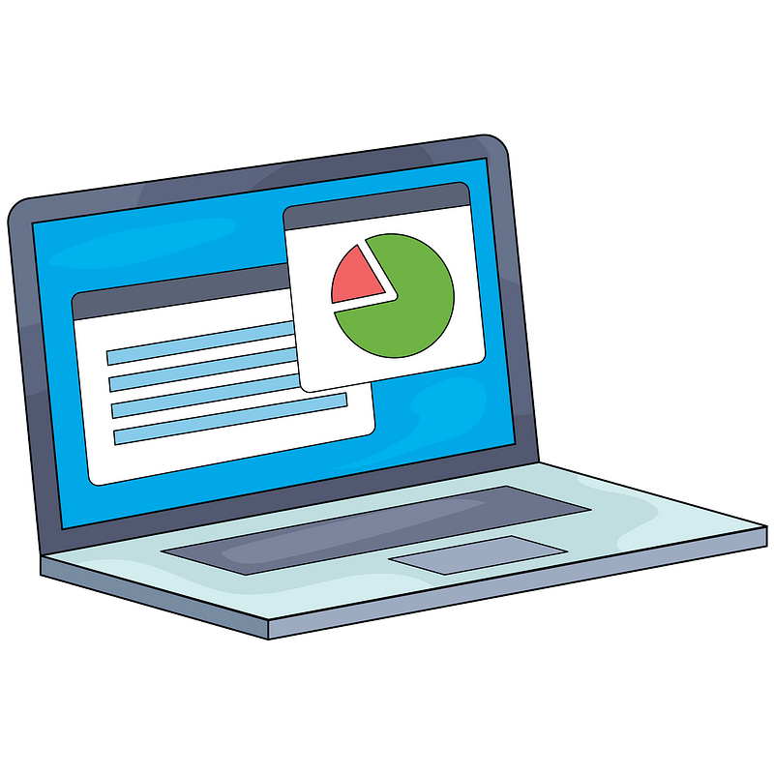

**Cell Phones**

1. Students must turn their phone off during class time and hallway transitions. (Therefore, the cell phone should not be out).
2. Student cell phones should be out of sight. They may be in a backpack or purse. Sitting on the desk is not acceptable.
3. Students must not use watches or keep them in airplane mode.
4. Students must turn in cell phones to receive a pass to use the restroom (that is the only time I should ever see your phone.
5. If your phone is seen or heard (it should be off) or if you have earbuds in, I will take them up and turn them in to the office.

**Distance Learning Attendance Policy**

**

**Technology Expectations**

* Bring your device to school each day fully charge (and bring your charging cord)
* Access only those apps, documents, websites, or other course materials, as directed by the teacher
* Devices are used in a manner that maintains the respect of oneself and others, including getting permission before taking pictures, and/or audio / visual recording.



**How to Get to Skyward:**

**Students:**

**Go to** [**www.sfisd.org**](http://www.sfisd.org) **> students > Skyward Student Access**

**Enter your name and password**

**Parents:**

**Go to** [**www.sfisd.org**](http://www.sfisd.org) **> parents > Skyward Family Access**

**Enter your name and password**

*Use the tabs on the left to view attendance, student info, schedule, report cards, & view or pay fees*