Sean Deflora
Daily Schedule After School
Tutorials
1st – English III
2nd – Conference Mon & Tue
3rd – English III
4th – English III
5th – English III
6th – English III
7th – English III
Classroom: D113
Conference Period: 2nd
Email: Sean.Deflora@sfisd.org
Ext: 3261

English III Syllabus

Course Description
English III is a rigorous course in which students will study the development of American thought and the American voice in literature. Students will critically read and evaluate various forms and types of texts including novels, poetry, informational texts and visual texts. English III is designed to emphasize independent thought and equip students to be successful members of an increasingly global society and economy.
Learning Objectives
In addition to various informational texts, speeches, short stories, and poetry, we will be reading the following long form novels: Of Mice and Men by John Steinbeck; The Crucible by Arthur Miller; The Great Gatsby by F. Scott Fitzgerald; The Things They Carried by Tim O’Brien.
Supply List (required):
- Your school supplied device OR device from home
- Power-cords to keep device battery charged
- Pencils or pen (there will be the occasional paper work)

Grading Scale
Essays and exams/Major Grades: 50%
Quizzes/Minor Grades: 30%
Daily Grades, homework: 20%

Tests/Exams Rules
- Students have two weeks to retest any major exam grade up to a 70% (excluding 9-wks exam and semester exam
- If a student fails to demonstrate mastery on the re-test, the higher of the two grades shall be recorded.

Make-Up Work
Students shall be permitted to make up assignments and tests after an absence. It is the student’s responsibility to ask for and to complete make-up work. The student has the number of days equal to the number of days missed in order to complete make up work and tests.

Late Work
The expectation is that all students will comply with all deadlines for class assignments. However, if the student does submit assignments past the deadline the teacher will adhere to the following for late assignments:

5 points deducted each day PAST the due date for a maximum deduction of 30 points (70% is still better than a 0!)

Remind App
I use the Remind App account for my classroom. This is a great way for me to send out assignment reminders and imperative information. Both students and parents can sign up for the account by following the instructions below. All students are HIGHLY RECOMMENDED to do this in order to stay up to date with information. All information is kept private and there is no way for me to ever know a student’s personal number or vice versa.
Instructions:
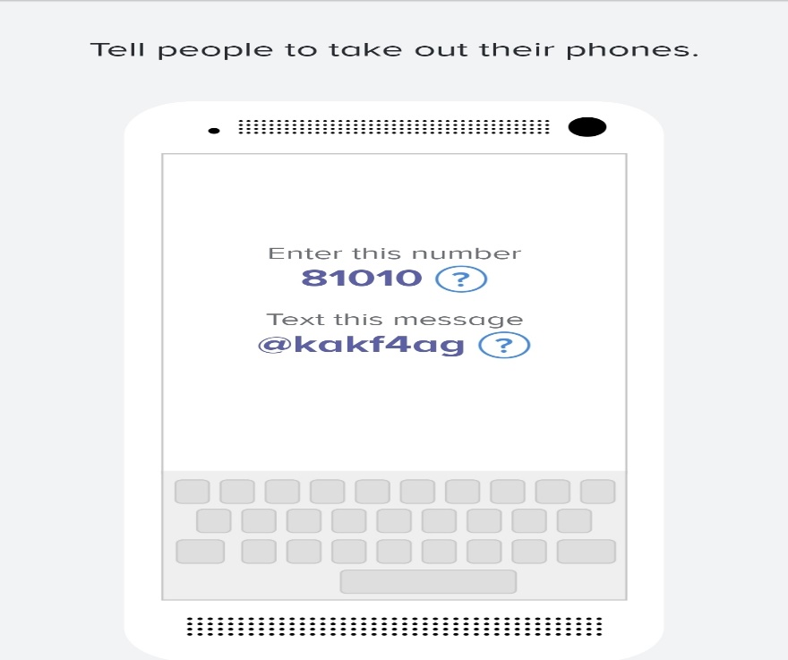
(if you are having trouble with 81010, try texting “@” to (315)790-6994)
Canvas Website Located on the Santa Fe High School webpage is my teacher website. This includes information about my class, tutorial times, weekly agendas, and all contact information. My modules are organized by WEEK and all assignments are dated making it easy to find missing work/ catch up on assignments.
*Assignments only remain visible during the 9 weeks, after which they will disappear.

CELL PHONE POLICY!
Students are expected to limit their cell phone use in my classroom. This is not a 100% ban on all usage, but a reminder to use your best judgment. For example, your phone should be away:
During direct instruction
Group work
Reading time
Tests or Quizzes

1st Offense – Verbal warning to put the cell phone away.
2nd Offense – Phone will be confiscated and returned at the end of class.
3rd Offense – Phone will be confiscated and turned into campus bookkeeper. The student and/or parent will be able to retrieve the phone at the end of the school day after paying a $15 fine.

TO SUMMARIZE, YOU WILL BE EXPECTED TO PERFORM THE FOLLOWING TASKS THROUGHOUT THE YEAR
- Type on a regular basis
- Work in groups
- Read out loud, in groups, and independently on a regular basis
- Use the CANVAS website
- Monitor workload and catch up if necessary through tutorials or after school
- Actively follow along if the class is reading together
- Keep phone in bag/pocket during instructional time
- Turn work in on time

