Review Questions UNIT 6
- During the process of photosynthesis, what type of energy conversion is occurring?
RADIANT ENERGY IS CONVERTED INTO CHEMICAL ENERGY
- What happens to light energy during the chemical reaction?
IT IS CONVERTED INTO CHEMICAL ENERGY DURING THE REACTION
- In a food chain, where is light energy being converted? Label and draw a food chain.

SUN GRASS GRASSHOPPER HAWK THE GRASS
- Why is it necessary to have sunlight in photosynthesis?
THE PROCCESS CANNOT OCCUR WITHOUT ENERGY FROM THE SUN
- Where is radiant energy from the sun being converted into chemical energy?
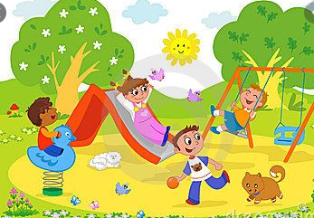
THE TREE, THE PLANTS, THE GRASS
- How much energy is passed on from one level of the food pyramid to the next?
10%
- What is an energy pyramid? Describe the flow of energy in the pyramid?
AN ENERGY PYRAMID IS A GRPHICAL REPRESNTATION SHOWING THE FLOW OF ENERGY FROM ORGANISM TO ORGANISM

EACH GROUP RECIEVES ONLY A SMALL AMOUNT OF THE ENRGY FROM THE LEVEL BELOW IT.
- What kind of energy is stored in food?
CHEMICAL

- What animal receives the most energy originally produced by the plants in the Food web?

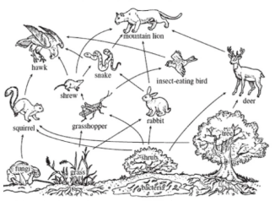
THE SQUIRREL, THE GRASSHOPPER, THE RABBIT, THE DEER

- Which consumers would receive the greatest amount of energy? Which consumers receive the least amount of energy? 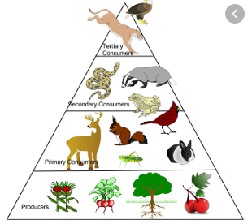
GREATEST AMOUNT OF ENERGY: DEER, GRASSHOPPER, RABBIT, SQUIRREL, CARDINAL
LEAST AMOUNT OF ENERGY: EAGLE, MOUNTAIN LION

11) What is the energy transfer that is occurring when an animal shivers? CHEMICAL TO THERMAL ENERGY

