1. Explain how the mitochondria could be compared to lights in a house.
   1. **They both provide usable energy for the house and the cell**
2. How is the vacuole different in a plant cell than an animal cell?
   1. **Plant cells have larger vacuoles**
3. **~~In the station activity what represented a vacuole?~~**
4. List the levels of organization.
   1. **Cell, tissue, organ, organ system, organism**
5. What is the function of the mitochondria?
   1. **Converts energy for cell use.**
6. What organelle allows waste to leave the cell?
   1. **The cell membrane**
7. What cell organelle contains the DNA?
   1. **Nucleus**
8. How can you tell the difference between a plant cell and an animal cell from a drawing?
   1. **Plant cells have a larger vacuole than an animal cell**
9. What organelles are found only in a plant cell?
   1. **Cell wall, chloroplast, large vacuole**
10. Draw a plant vacuole in a plant cell and label it.
11. Draw animal vacuoles in an animal cell and label it.
12. What kind of cell contains the following: cell wall, nucleus, cell membrane and chloroplast?
    * 1. **Plant**
13. What cell organelle has a function that is similar to a refrigerator?
    * 1. **Vacuole**
14. What organelle can be described as a gel-like fluid that maintains pressure inside the cell?
    * 1. **Cytoplasm**
15. What organelle provides the plant cell with structure?
    * 1. **Cell wall**
16. In what type of cell would you find multiple smaller vacuoles?
    * 1. **Animal cell**
17. Name the organelle that converts sunlight into food for the cell?
    * 1. **Chloroplast**
18. Your body has a brain to control your actions, what organelle does a cell have that performs similar functions?
    * 1. **Nucleus**
19. What do all living organisms have in common?
    * 1. **They all contain cells.**
20. According to the cell theory, what does a mushroom, rabbit and a tree have in common?
    * 1. **Contain cells that are the basic unit of structure for each.**
21. What organelle’s function is to transport proteins throughout the cell?
    * 1. **Endoplasmic reticulum**
22. How do you explain why all cells on your tongue look identical to one another? (Think Cell Theory)
    * 1. **All cells come from other cells through division**
23. What are the 3 parts to Cell Theory?
    * 1. **All living organisms are composed of 1 or more cells.**
      2. **The cell is the basic unit of life.**
      3. **All cells come from other cells**
24. All organisms are composed of 1 or more_**cells_**________.
25. Tissues make up _____________**organs___________.**
26. What is the 2nd Level of Organization?
    * 1. **Tissues**
27. List 6 lab safety rules:

**Use a wafting motion to smell something**

**Wear goggles**

**Ask teacher for help when you spill something**

**No horseplay in the lab**

**Wear apron**

**Do not eat in the lab**

1. Organ Systems make up __**organisms_________________________.**
2. What are the primary organs of the respiratory system?
   * 1. Lungs, trachea and bronchioles
3. What are the functions of the respiratory system?
   * 1. Warms the air, exchanges O and CO2, creates sound
4. Where does the respiratory system begin?
   * 1. Nose and mouth
5. Where in the lungs does gas exchange occur?
   * 1. Alveoli
6. The small flap of cartilage that closes when food passes is called?
   * 1. Esophagus
7. What passageway is part of both the respiratory and digestive system?
   * 1. Pharynx
8. What carries air to the left and right bronchus?
   * 1. Trachea
9. What are the tree like branches coming off the bronchus called?
   * 1. Bronchioles
10. What is the organ that holds the vocal cords?
    * 1. Larynx
11. What is the PLT?
    * 1. Pharynx, Larynx and Trachea
12. What is the function of the Circulatory system?
    * 1. Transports nutrients and oxygen to the body
13. Which blood vessel carries blood away from the heart?
    * 1. Arteries
14. Capillaries are…?
    * 1. Distribution pipe
      2. Tiny blood vessels
15. The _______ is the largest vein in the body?
    * 1. Vena Cava
16. To pump and circulate blood is the works of what organ?
    * 1. Heart
17. What makes up the 3% of blood plasma?
    * 1. Red Blood Cells
      2. White Bloods Cells
      3. Platelets
18. The heart contains how many chambers?
    * 1. 4
19. The atria is the receiving chamber? The Ventricles are
    1. the pumping chambers? The valves controls flow? The Septum divides the heart?
20. Which blood vessel carries blood into the heart?
    * 1. Veins
21. The circulatory system works closely with which other system?
    * 1. Respiratory system
22. The _______ produces sperm.
    * 1. Testes
23. Female reproductive organs produce more eggs as they grow?
    1. True or False
24. What part of the body delivers sperm?
    1. Penis
25. What hormone do the testes secrete?
    * 1. Testosterone
26. Where do eggs grow and mature?
    * 1. Ovaries
27. What is the function of the human reproductive system?
    * 1. Produce offspring
28. Which reproductive system is found outside of the body?
    * 1. Male Reproductive system
29. Which reproductive system is found on the inside of the body?
    * 1. Female Reproductive system
30. What is the fluid called that protects the sperm?
    * 1. Semen
31. What are the female and male reproductive organs?
    * 1. Sperm ducts
      2. Penis
      3. Prostate Gland
      4. Testes
      5. Ovaries
      6. Fallopian Tubes
      7. Uterus
      8. Vagina

What can you infer about the structure in the picture below?

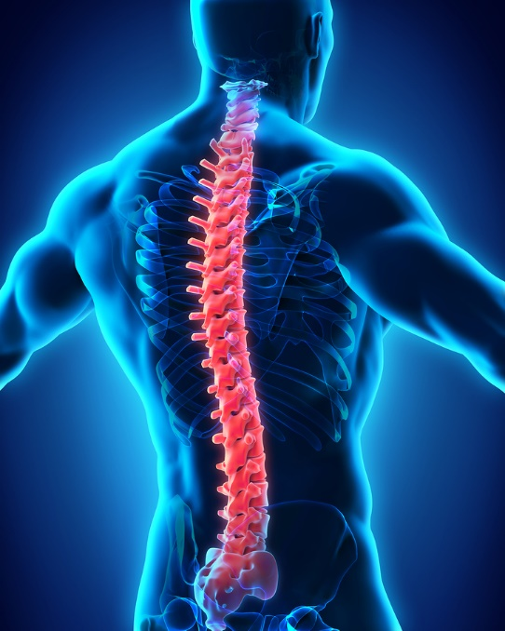

**Spinal Cord**= Central communication system.

* + Nerve center
  + Messages are sent to the brain through the spinal cord
  + Exception: Reflexes skip the spinal cord and go straight to the brain

What is the function of the skeletal system?

1. Framework gives shape & support to the body.

2. Bones protect the internal organs.

3. Major muscles of the body are attached to the bones.

4. Blood cells are formed in red marrow of some bones.

5. Skeleton is a place where major quantities of **calcium** and **phosphorus** compounds are **stored.**

What can infer about the structure in the picture?

[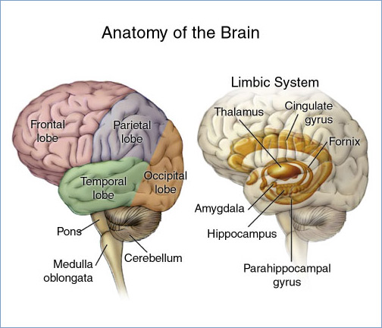](http://commons.wikimedia.org/wiki/File:Brain_headBorder.jpg)

**Brain**= uses information it receives from nerve impulses to coordinate actions

What system does the picture show? What are the functions of this system?

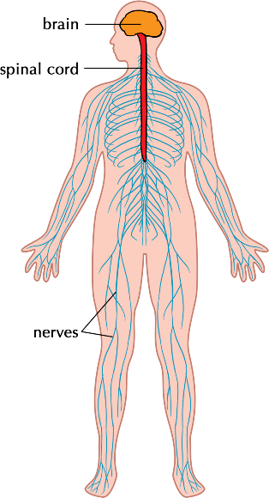 Nervous System

* + Control center
  + Communication network

Coordinates all actions and reactions

-Send messages as electrical impulses

What system does the picture show? What are the functions of this system?

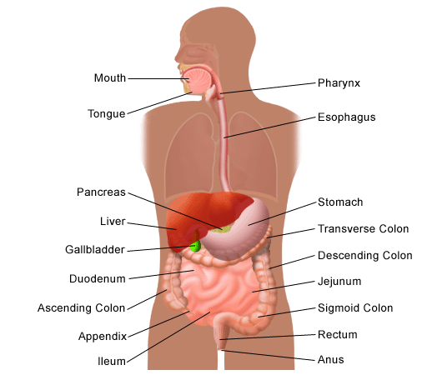Digestive System

Digestion is the breakdown of food, which are then absorbed into the body and provides us with energy

What can you infer about the picture below?

The digestive system. The first part of breaking down food occurs in the mouth when you chew your food.

What system does the picture show? What are the functions of this system?

[](http://commons.wikimedia.org/wiki/File:Bicep_tricep.gif)Muscular System

* Protects vital organs and tissues
* Provides framework for mobility
* Produces new red blood cells

When muscles __________contract______________, they get shorter.

When muscles _________expands_______________, they become longer.

How many different tissues does the muscular system have? What are they?

3

Skeletal

Smooth

Cardiac

Why is the cardiac muscle so important to our body?

**Cardiac** Muscle

* + - Only found in **heart**
    - Contracts **70** times per minute (**heartbeat**)
    - Keeps us alive

What are the organs in the digestive system?

Mouth, Esophagus, Liver, Stomach, Gall Bladder, Pancreas, Small and Large Intestine, Appendix, Rectum, Anus

What are the organs in the nervous system?

Brain, Nerves and Spinal Cord

The muscle is considered what in the muscular system?

An organ

Define Voluntary and Involuntary

**Voluntary**—You **can** control these.

* + - **Arms, legs, hands, face**

**Involuntary**—You **can’t** control these; you don’t have to decide to make these muscles work.

* + - Muscles around the **heart**

What are the 2 different energies the body uses in the muscular system? Hint: Movement and Heat

Mechanical – movement

Thermal - heat

Define joints and the 2 types of joints in the body.

Any place where **two** or more bones **meet**

Moveable – allows movement in a variety of ways

Immoveable – Little or no movement

How many muscles are in the body?

More than 600

How many bones are in the body?

206

1. Define heredity.

The passing of genes from parent to offspring

1. Define sexual reproduction and give an example.

Reproduction in which the genetic material comes from two different cells and combine to produce an offspring. Ex. Humans, birds, dogs, snakes

1. Define asexual reproduction and give an example.

Reproduction in which the genetic material comes from one cell and produces an offspring. Ex. Regeneration of a gecko tail, sea stars, cactus, strawberries

1. What is the difference between trait and allele?

Trait is the “category” that is passed down from our parents and allele is the “specific to the category” that our parents give us. Ex. Trait – hair Allele – dominant and recessive color of hair

Different forms of a trait are alleles

1. Define heterozygous and give an example.

Two genes of a chromosome are Different such as Bb

1. Define homozygous and give an example.

Two genes of a chromosome are the same such as BB, bb

1. What is the difference between dominance and recessive genes?

Dominate Traits will overpower the recessive traits. If the Dominate trait is present, the dominate trait will always show over a recessive trait. A dominate trait is represented by a CAPITAL LETTER. In order for a recessive trait to show, there must be two recessive alleles present. Recessive traits are represented by lowercase letters.

1. Batman and Catwomen met at a crime scene. They both fell in love and decided to get married. Batman is homozygous for brown hair but he has dyed his hair black because it started to turn grey. Catwomen is heterozygous for brown hair. Create a Punnett square that shows the possibilities if they had a child. Use B to represent the dominant gene and b to represent the recessive gene
2. List the possible genotypes and phenotypes for their children.

BB, Bb/Brown hair

1. What is the percent chance of a child with brown hair?

100%

1. What is the percent chance of a child with different color hair?

0%

1. What is the percent for heterozygous genotypes?

50%

1. What is the percent for homozygous genotypes?

50%

**B B**

**b**

**B**

|  |  |
| --- | --- |
| BB | BB |
| Bb | Bb |