Semester I Review for December 18, 2019

- Which of the following is an element or a compound?
- C = _______________________
- H2O = _______________________
- NaCl = _______________________
- O = _______________________
How do we always know which is an element and which is a compound? COUNT THE CAPITAL LETTERS; an element only has one capital letter and a compound has 2 or more capital letters.

- When 2 or more substances are combined; how do we know a chemical reaction has occurred?

- What 3 types of reactions show us that a chemical reaction has occurred?
_______________________
_______________________
_______________________

- What are 5 properties of nonmetals?
_______________________
_______________________
_______________________
_______________________
_______________________

- Which of the following are either malleable or conduct electricity?
- Sulphur = _______________________ & _______________________
- Chlorine = _______________________ & _______________________
- Aluminum = _______________________ & _______________________

- Which answer has a density of 1.62 g/cm3
Metal | Mass (g) | Volume (cm3)
1 | 32.2 | 5.00
2 | 52.1 | 6.00
3 | 11.34 | 7.00
4 | 10.15 | 5.00

- What physical property is tested when you rub a mineral across a tile to see the color of its residue? _______________________

- What physical property is tested when you scratch a mineral with a nail or a steel tool? _______________________

Hardness | Mineral
1 | Talc
2 | Gypsum
3 | Calcite
4 | Fluorite
5 | Apatite
6 | Feldspar
7 | Quartz
8 | Topaz
9 | Corundum
10 | Diamond

Refer to the above Mohs Hardness Scale table. Which of the following is true about a mineral with a hardness of 5?
- This mineral can scratch Topaz but not Talc
- This mineral can scratch Feldspar but not Fluorite
- This mineral can scratch Gypsum but not Quartz
- This mineral can scratch Corundum but not Calcite

- When a person is at the TOP of a mountain, his _______________________ is the greatest and his _______________________ is the least.

- When a person is at the BOTTOM of a mountain, his _______________________ is the greatest and his _______________________ is the least.

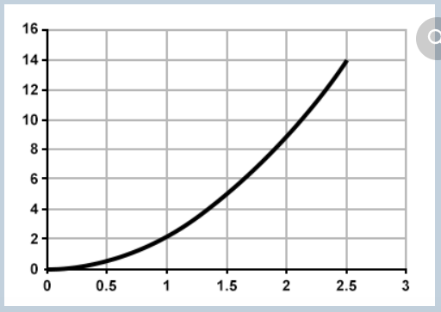

This is an _______________________ graph. It changes it’s _______________________ throughout the measurement.

- Cynthia threw a rock high into the air. As the rock rises in the air, it is acted on by the force of gravity. This force causes the rock to _______________________, _______________________ and then _______________________ until it falls to the ground.

- Average speed is distance divided by time (d/t). If a truck travels 30 km in 30 minutes, then what is the average speed of the truck. (Remember, this problem only gives you 30 minutes, so you need to double your answer to get the average speed per hour).

- A football player kicks a football three times. Each time, the distance and speed are recorded.
Kick | Distance (m) | Time (s) | Average speed (d/t)
1 | 45 | 5.0 | 9
2 | 40 | 5.0 | 8
3 | 20 | ??? | 2

How many seconds did it take for the football to travel 20 m during Kick 3?

- Draw a speed graph for the following: A toy car moves forward, at a constant speed, slows down and then stops.
- Draw a speed graph for the following: Angela walks 2.5 km to SFJH in 10 minutes. Then she walks another 2.5 km to the store in 10 minutes.

- The steeper or _______________________ the inclined plane, the more force needed to push an object to the top.

- The _______________________ the inclined plane, the less force needed to move an object.

- Chemical energy in natural gas transforms to _______________________ energy which transforms to _______________________ energy.

- When Kenny ate a hamburger and then used the energy from the hamburger to run, Kenny converts _______________________ energy to _______________________ energy.

- _______________________ is the resource most affected by changes in weather.

- _______________________ only produces energy when the sun is shining.

