- T.J. and Lindsey’s lunch costs $30. They want to leave a 20% tip for their waiter. Use the model below to determine the amount of the tip.

Which amount is the closest to the amount of the tip that they will leave their waiter?
- $36.00
- $6.00
- $20.00
- $3.00

- At t local high school football game, 30% of the fans were sitting in the student section of the stadium. Ms. Flores counted 225 people sitting in the student section. Which model could be used to determine how many total fans were at the game?

- Mrs. Hector’s records show that 44% of her students bring their own lunch to school. Which decimal and fraction represents the percent of students in Mrs. Hector’s class who do NOT bring their lunch to school?

- 0.56 and $\frac{14}{25}$
- 0.44 and $\frac{11}{25}$
- 0.056 and $\frac{14}{25}$
- 0.044 and $\frac{11}{25}$
- The shaded model represents 100%.

Which model represents 66 2/3%?

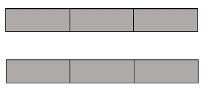

- According to a survey conducted by the Texas Free Press, 125 out of 500 people do not have internet access at their homes. What percent if the people surveyed DO have internet at their home?

- 12.5%
- 25%
- 37.5%
- 75%

- There are 25 students in Mrs. Carroll’s class. Seventeen of the students in her class rode the bus home today. The rest walked home. Which model best represents the percentage of students that rode the bus home and the percentage of students who walked?

- 12% Walked
68% Rode the Bus

- 68% Walked
12% Rode the Bus

- 8% Walked
17% Rode the Bus

- 17% Walked
25% Rode the Bus
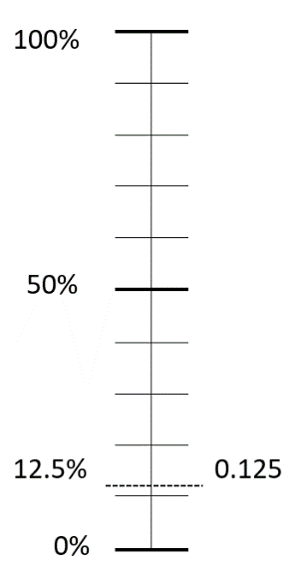
- The school spirit club ordered shirts to sell as a fundraiser. The model below shows the percent and decimal of the shirts they ordered that were blue.

Which fraction represents the portion of the order that were blue shirts?
- $\frac{1}{12}$
- $\frac{1}{8}$
- $\frac{12.5}{10}$
- $\frac{125}{100}$

- Joel bought a new baseball glove for $24.00. He received a discount of 20% off the original price.

Which fraction or decimal is equivalent to 20%?

- $\frac{2}{5}$
- $\frac{1}{20}$
- 0.2
- 2.0

- Which of the following is equivalent to 120%?

- $1\frac{1}{20}$
- 12.0
- $\frac{6}{5}$
- 0.12

- Which of the following is NOT equivalent to 0.45?

- $\frac{45}{100}$
- 45%
- $\frac{11}{20}$
- $\frac{18}{40}$

- Melissa asked 50 students in her class which fruit they preferred. The table below shows the result of her survey.
Fruit Survey
Type of  Fruit | Number of Students
Apples | 13
Bananas | 25
Oranges | 12

What decimal represents the fraction of the students who prefer oranges?
Record your answer on the grid below. Be sure to use the correct place value.
