UNIT 8 TEST REVIEW

- Y = 5x
Y = x + 5

- In Y = 5x and Y = x + 5, the value of Y is 5 more than the value of x.
- In Y = 5x the value is Y five times the value of x, and in y = x + 5 the value of Y is 5 more than the value of x.
- In Y = 5x the value is 5 more than the value of x, and Y = x + 5 the value of Y is five times the value of x.
- In Y = 5x and Y = x + 5, the value of Y is five times the value of x.

2)

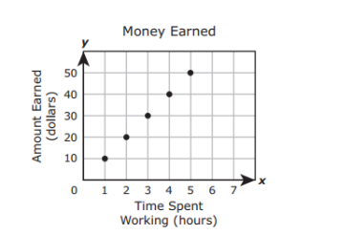
Which list shows the dependent quantities in the graph?
- 101, 202, 303, 404, 505
- 10, 20, 30, 40, 50
- 11, 22, 33, 44, 55
- 1, 2, 3, 4, 5

3)
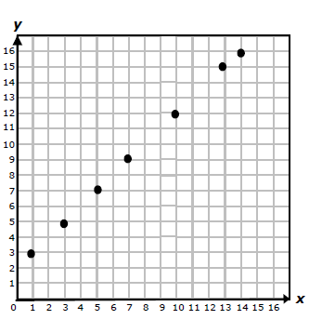
Which list best represents the independent values of the graphed points?
- 3, 5, 7, 9, 12, 15, 16
- 10, 20, 30, 40, 50, 60, 70
- 1, 3, 5, 7, 10, 13, 14
- 30, 50, 70, 90, 120, 150, 160

4) The table below shows how much money Mrs. Broussard spends on her babysitter. Which equation best represents the relationship?
Number of Hours (h) | Amount Earned (d)
2 | 18.00
3.5 | 31.50
5 | 45.00
7 | 63.00
8.5 | 76.50

A) d = h + 9
B) h = 9d
C) h = d + 9
D. d = 9h

5)
- 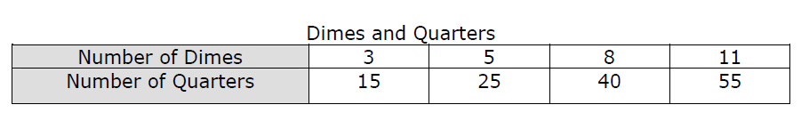

- 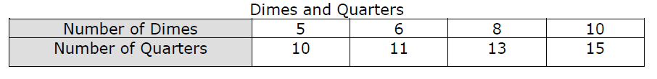

- 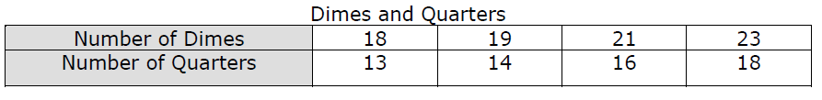

- 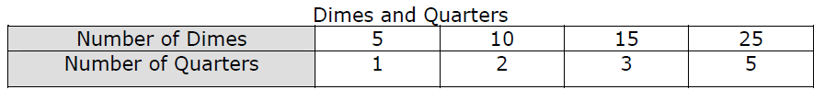

6) The which situation can be represented by this equation y = 6x ?
A) A class has y boys. The number of boys is 6 more than the number of girls.
B) One pice of string is y units long. It is 6 inches shorter than another piece of string.
C) Joanie read y pages of her history assignment. She read 6 times as many pages as Beth read, x.
D) Cindy had x pictures to place in a photo album. She will put 6 pictures on each page. How many pages, y will
she need for her pictures.

7)
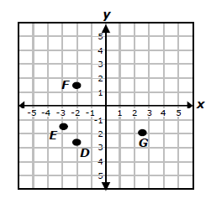
Which ordered pair is not appear to be repesented by one of these points?
- (-2, 1$\frac{1}{2}$ )
- (-2$\frac{1}{2}$ , 2)
- (2$\frac{1}{2}$ , -2)
- (-3, -1$\frac{1}{2}$ )

8)
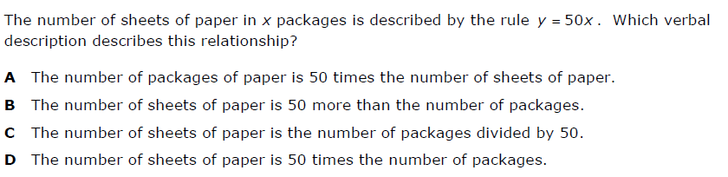

9) MS. Hector graphed a point S on the coordinate grid. Ms. Caroll graphed a point P 3 units away from point S.

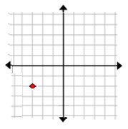
S
Which ordered pair could represent the location of point P?
- (-3, 2)
- (-1, -2)
- (-3, 1)
- (1, 2)

10) Ms. Pathirage grades 105 tests per hour. Which table represent the relationship between number of hours(h) and the number of tests(t).
A)
Hours(h) | Tests(t)
1 | 105
2 | 220
3 | 345

B)
Hours(h) | Tests(t)
2 | 210
4 | 420
8 | 840

C)
Hours(h) | Tests(t)
105 | 1
210 | 2
315 | 3

D)
Hours(h) | Tests(t)
3 | 330
4 | 450
5 | 550

