- Which number represents a whole number?
- -8
- 12 ÷ 5
- -10
- $\frac{24}{3}$

- Which describes an integer?
- Any number found on a number line.
- All numbers less than 0.
- The set of whole numbers and their opposites.
- None of the above.

- This Venn Diagram shows the relationship of the rational numbers.
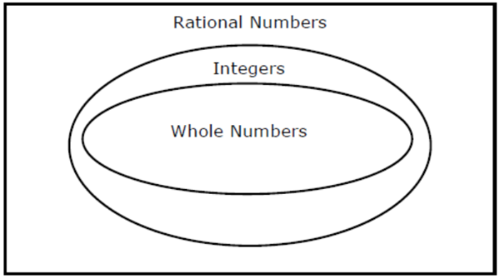

Which of the following is an integer but NOT a whole number?
- $\frac{2}{3}$
- -3
- $\frac{24}{2}$
- 32.5

- Which list contains exactly 3 whole numbers and 2 rational numbers that are NOT whole numbers?
- { 4, 8, -3, $\frac{4}{3}$, 10 }
- { 2, 16, -8, $\frac{5}{4}$, 6.1 }
- { 4.15, 6, 8, $\frac{9}{2}$, -12 }
- { 5, 14, -8, 2, 12 }

- Alyssa will correctly label and number 48.4, 48$\frac{1}{2}$, 48.09, and 48$\frac{3}{5}$ on the number line.

Which number will be located closest to 49?
- 48.4
- 48$\frac{1}{2}$
- 48.09
- 48$\frac{3}{5}$

- Order the set of numbers from least to greatest.
-3 4 -8 2 5 0
A. 0, -8, -3, 2, 4, 5
B. -3, -8, 0, 2, 4, 5
C. -8, -3, 0, 2, 4, 5
D. 0, 2, -3, 4, 5, -8

Rainfall in College Station
Month | Inches
March | 4.86
April | 3.16
May | 0.80
June | 1.44
July | 2.03
August | 1.77
- The table below shows the amount of rainfall in College Station from the last 6 months.

Which list shows the rainfall in inches from greatest to least?
- March, August, July, April, June, May
- March, April, July, August, June, May
- May, June, August, July, April, March
- May, June, April, July, August, March

- Which list shows the temperatures in order from coldest to warmest in the degrees Fahrenheit?
- -1°F, 18°F, -4°F, 6°F
- 5°F, -6°F, 0°F, -8°F
- -12°F, -6°F, 0°F, 6°F
- 0°F, -3°F, 6°F, -12°F
- Order the set of numbers from greatest to least.
2$\frac{5}{8}$ 2$\frac{3}{4}$ 2$\frac{7}{8}$ 2$\frac{1}{8}$ 2$\frac{1}{2}$
- 2$\frac{1}{2}$, 2$\frac{3}{4}$, 2$\frac{1}{8}$, 2$\frac{7}{8}$, 2$\frac{5}{8}$
- 2$\frac{7}{8}$, 2$\frac{3}{4}$, 2$\frac{5}{8}$, 2$\frac{1}{2}$, 2$\frac{1}{8}$
- 2$\frac{1}{8}$, 2$\frac{1}{2}$, 2$\frac{5}{8}$, 2$\frac{3}{4}$, 2$\frac{7}{8}$
- 2$\frac{5}{8}$, 2$\frac{3}{4}$, 2$\frac{7}{8}$, 2$\frac{1}{8}$, 2$\frac{1}{2}$,

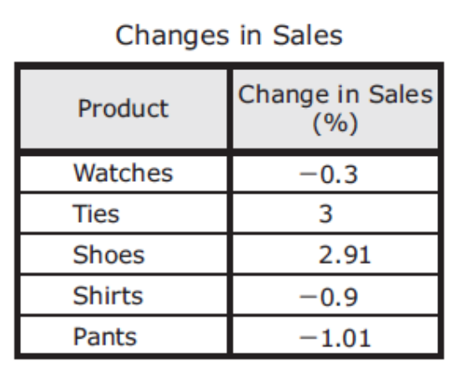
- A store manager analyzed the change in sales of various products from last month to this month. The percent increases and decreases in sales are shown in the table.

These values will be ordered from greatest to least. Which list of the products matches the order?
- Pants, shirts, watches, shoes, ties
- Ties, shoes, watches, shirts, pants
- Watches, shirts, pants, shoes, ties
- Ties, shoes, pants, shirts, watches

- Which describes a rational number?
- Any number found on a negative number line.
- All numbers greater than 0.
- Numbers that can be written as fractions, terminating decimals, and repeating decimals.
- Only decimal numbers.

