Unit 7 Review
- The area of a rectangular dog run can be no more than 120 square feet. The base is 15 feet. Which inequality represents all the possible lengths in units of the height, h, that can be used to construct the dog run?

- h ≥ 1,800
- h ≤ 8
- h ≥ 135
- h ≤ 105

- Jenny is selling plants for a fundraiser. She sold 8 plants for a total of $92. What was the price of each plant?
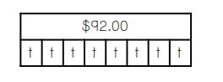
- $100
- $2.00
- $11.50
- $736

- Which number line represents the solution to 5x ≥ 30?
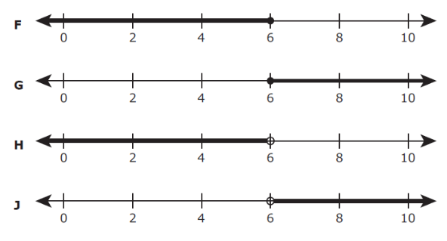
- Liang has a goal of walking at least 18 miles. She walks at a rate of 4 miles per hour. Which inequality can Liang use to find h, the number of hours she should walk in order to meet or exceed her goal?

- 4h ≥ 18
- 4h ≤ 18
- h + 4 ≥ 18
- h + 4 ≤ 18
***Study hint: Be sure you know the meaning of the word “maximum” for the test.

- Which expression in equivalent to 10 ÷ (2 + x) ?

- (2 + x) ÷ 10
- (2 ÷ 10) + x
- 10 ÷ 2 + 10 ÷ x
- 10 ÷ (x + 2)

- Which two expressions are equivalent?

F) 9(6 + x) and 9 * 6 + 9 * x
G) x + (8 * 9) and (x + 8) * 9
H) 8 * 6 ÷ x and 8 * x ÷ 6
J) 6 * x + 3 and 6 * (x + 3)

- Which of the following represents the prime factorization of 80?
- 2⁴ * 5
- 2² * 4 * 5
- 2⁵ * 5
- 2 * 5

- Which value is equivalent to the expression below?

60 – (9$÷$3)² + 15

A. 66
B. 72
C. 42
D. 56

- Which situation can be represented by 17.35x > 624.60?
F) A waitress had received a $17.35 tip. This brought her total in tips to more than $624.60. How much money in tips did she have before the $17.35?
G) Brianda made a deposit of $17.35 into a savings account. This brought the total in her savings account to $624.60. How much money did she have in this savings account before she made the deposit?
H) A dozen tamales cost $17.35, including tax. How many dozen tamales can a customer buy with $624.60?
J) Darren earns $17.35 per hour at his job. How many hours does he need to work in order to earn more than $624.60?

- What is the value of the expression below when the value of x is 5?
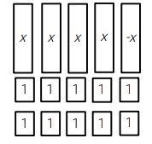

- 18
- 12
- 25
- 150

