UNIT 9 Test Review

- Mrs. Dona created a flower bed in a shape of a triangle in her back yard. Use the ruler and measure the dimensions to the nearest centimeters.
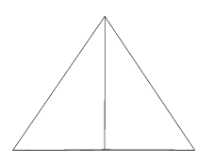

Which measurement is closest to the area of the flower bed in square centimeters?
A 20${ cm}^{2}$
B 9 ${cm}^{2}$
C 10 ${cm}^{2}$
D 15 ${cm}^{2}$

- A rectangle base of a box is shown. Use the ruler and measure the length and width of the rectangle base to the nearest $\frac{1}{4}$ inch.

The height of box is 11 Inches. What is volume of the rectangular prism?

A 11 ${in}^{3}$

B 70 ${in}^{3}$

C 15.5 ${in}^{3}$

D 117 ${in}^{3}$

3. A table top in a science lab is shaped like a trapezoid. The dimensions of the table are shown below inches.
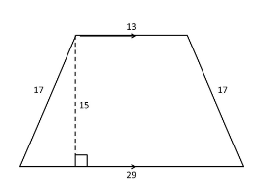
What is the area of the area of the table top in square inches?
A 29.5 ${in}^{2}$
B 315 ${in}^{2}$
C 357 ${in}^{2}$
D 28.5 ${in}^{2}$

4. 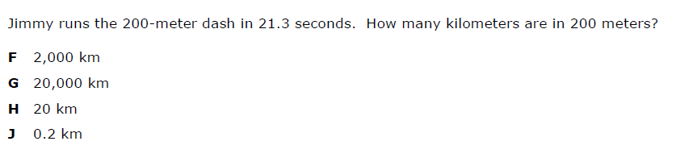

5. A rope is 9060 feet long. How long is the rope in yards?
A 27,180 yd
B 108,720 yd
C 4530 yd
D. 3020 yd

6. Which set of angle measure CANNOT be the angle measures of a triangle?
A 95°, 50°, 35°
B 90°, 45°, 45°
C 80°, 45°, 63°
D 100°, 20°, 60°

7. In Triangle NPQ shown below, What is the measure of ∠ N in degrees
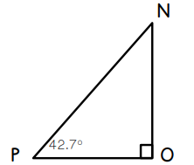
Record your answer and fill in the bubbles. Be sure to use the correct place value.

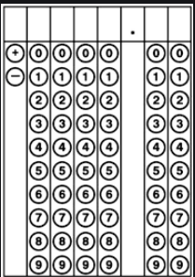
8. A dimensions of a trapezoid is shown in a diagram. Which equation can be used to find A, the area of the trapezoid in square centimeters?
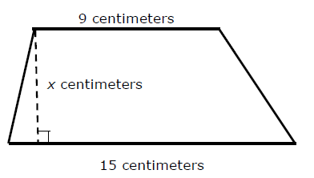
m Centimeters

A A= $\frac{1}{2}$ ( 9 + 15) m
B A= $\frac{1}{2}$ (9) +(5)x
C A = $\frac{1}{2}$ (9 + 15)x
D A = $\frac{1}{2}$ (9) + (15)m

9. The table shows the relationship between the Area of Triangle and Area of Rectangle.
Area of Triangle (T) | Area of Rectangle (R)
2.5 | 5
3 | 6
4 | 8
5.5 | 11

Which equation can be used to find T, the area of a Triangle from R, area of a Rectangle?
A T = R - 2.5
B T = $\frac{R}{2}$
C T = T + 3
D T = R + 4

10. The figure represents a small container that takes a shape of rectangular prism. The dimensions of the container are given below. The container is filled with sugar. What is the volume of the sugar in the container?

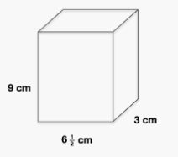
A 18.5 ${cm}^{3}$
B 175.5 ${cm}^{3}$
C 35.1 ${cm}^{3}$
D 20.9 ${cm}^{3}$

