AP Stats
Chapter 1 1.1 Outline
VOCABULARY

Categorical variables place individuals into one of several groups or categories.

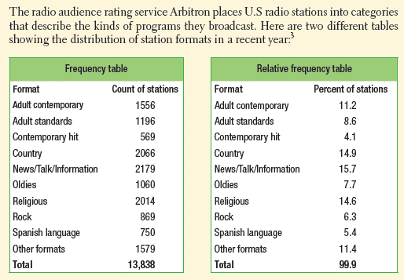

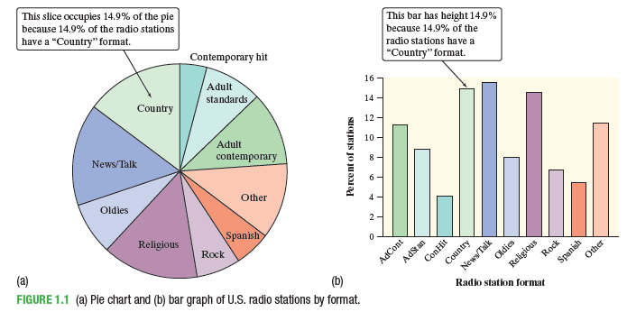
- When you draw a bar graph ____________________________________________________________

Do not replace the bars with pictures for greater eye appeal.
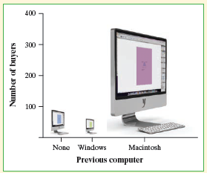
- Beware of the pictograph
- Watch the scales

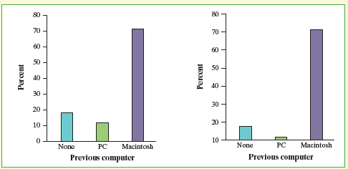

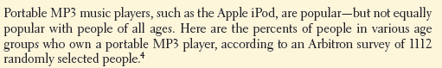
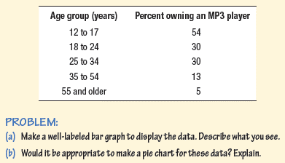

When a dataset involves TWO categorical variables, we begin by examining the counts or percents in various categories for one of the variables.

- A two-way table describes TWO categorical variables, organizing counts according to a _____________ variable and a ________________ variable.

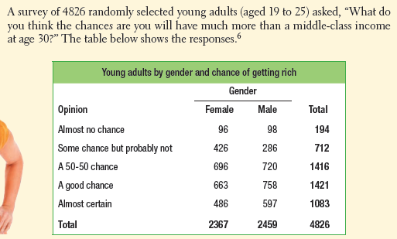
What are the variables described by this two-way table?

How many young adults were surveyed?

- The marginal distribution of one of the categorical variables in a two-way table of counts is the distribution of values of that variable among all individuals described by the table.
- Percents are more informative than counts.

How to examine a marginal distribution:
  - Use the data in the table to calculate the marginal distribution (in percents) of the row or column totals
  - Make a graph to display the marginal distribution.

