AP Stats
Chapter 1 1.2 (day 2) Notes Outline
Some of the most interesting statistics questions involve comparing two or more groups. You should always discuss Center, Unusuals, Shape and Spread when comparing the two distributions of quantitative variables!
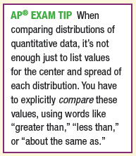
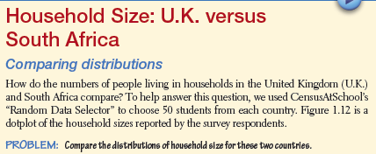
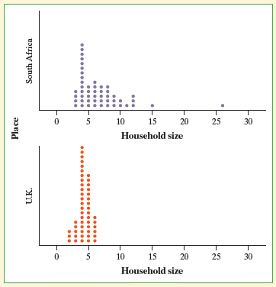

Another simple graphical display for fairly small data sets is a stemplot (also called stem and leaf plot). They give us a quick picture of the shape of a distribution while including the actual numerical values in the graph. We will learn how to create and read a stemplot.

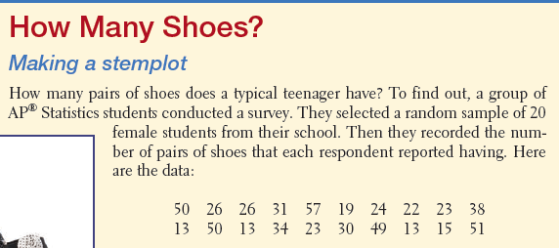
Following are the steps to make a stemplot:
- Separate each observation into a stem, consisting of all but the final digit, and a leaf, the final digit. Write the stems in a vertical column with the smallest at the top and draw a vertical line at the right of this column. Do not skip any stems, even if there is no data value for a particular stem.
- Write each leaf in the row to the right of its stem.

- Arrange the leaves in increasing order OUT from the stem.

- Provide a key that explains in context what the stems and leaves represent.

Data on male students:
