AP Stats
Chapter 1 1.1 (day 2) Outline

Marginal distribution tells us NOTHING about the relationship between the two variables. To describe a relationship between two categorical variables, we must calculate percents from the counts given in the body of the table. This is called a conditional distribution.

A conditional distribution of a variable describes the values of that variable among individuals who have a specific value of another variable. There is a separate conditional distribution for each value of the other variable.

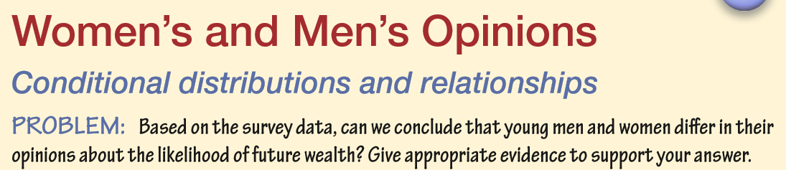
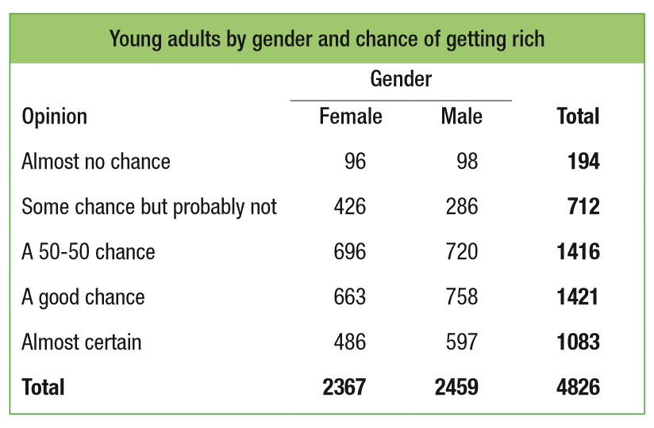

Both graphs provide evidence of an ________________________________between gender and opinion about future wealth in this sample of young adults.

We say that there is an association between two variables if knowing the value of one variable helps predict the value of the other. If knowing the value of one variable does not help you predict the value of the other, then there is no association between the variables.

