AP Stats
Chapter 1 1.2 (day 3) Notes Outline
How to make a histogram:
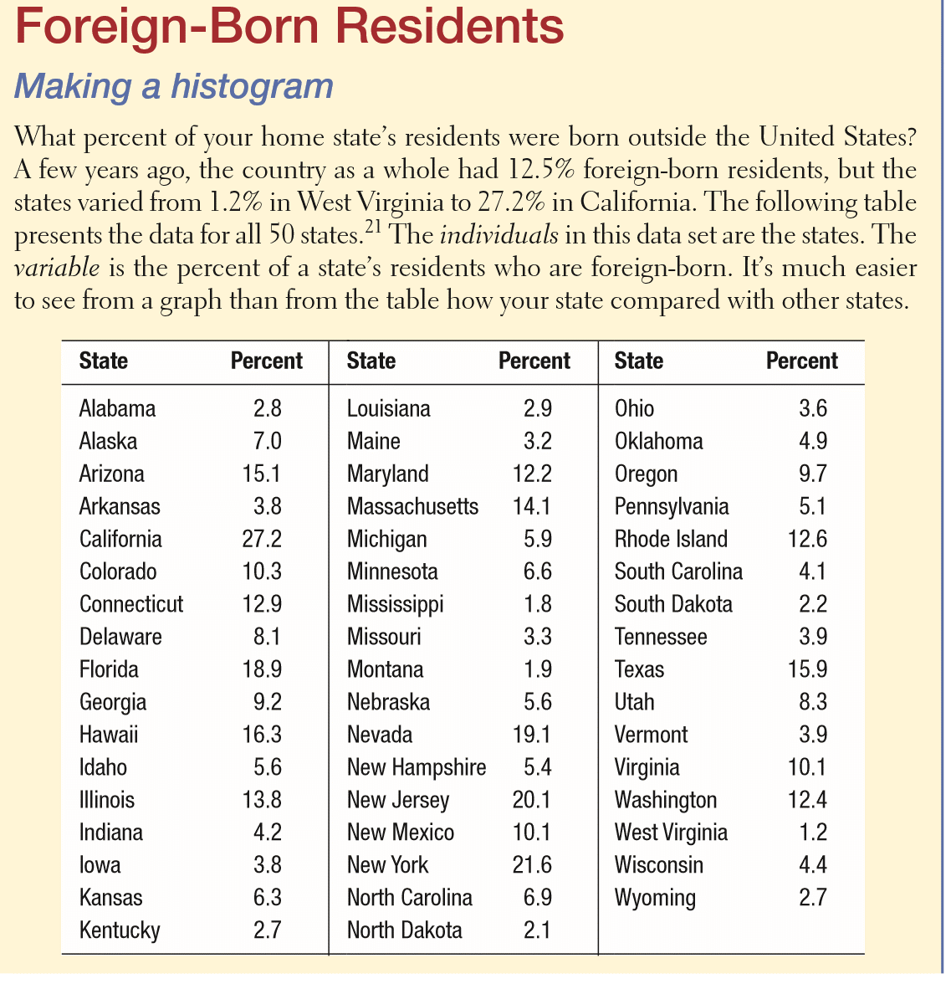
- Divide data into classes of equal widths.

- Find the count (frequency) or percent (relative frequency) of individuals in each class.
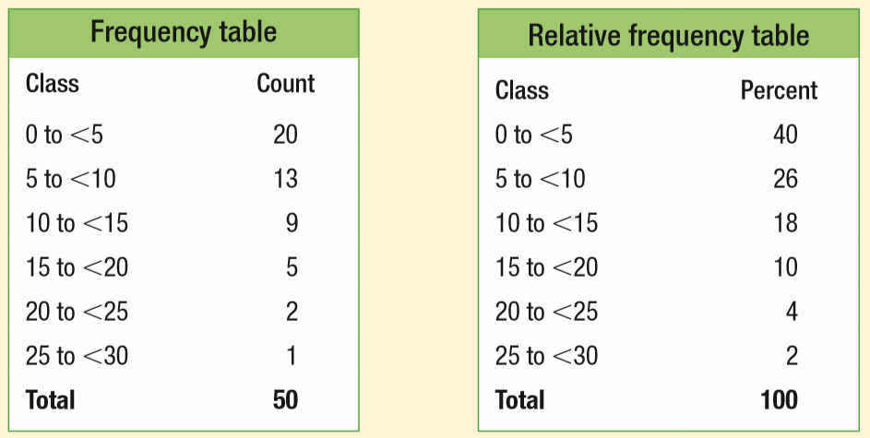

- Label and scale your axes and draw the histogram.

What do the histograms tell us about the percent of foreign born residents in the states? (cuss and bs!)

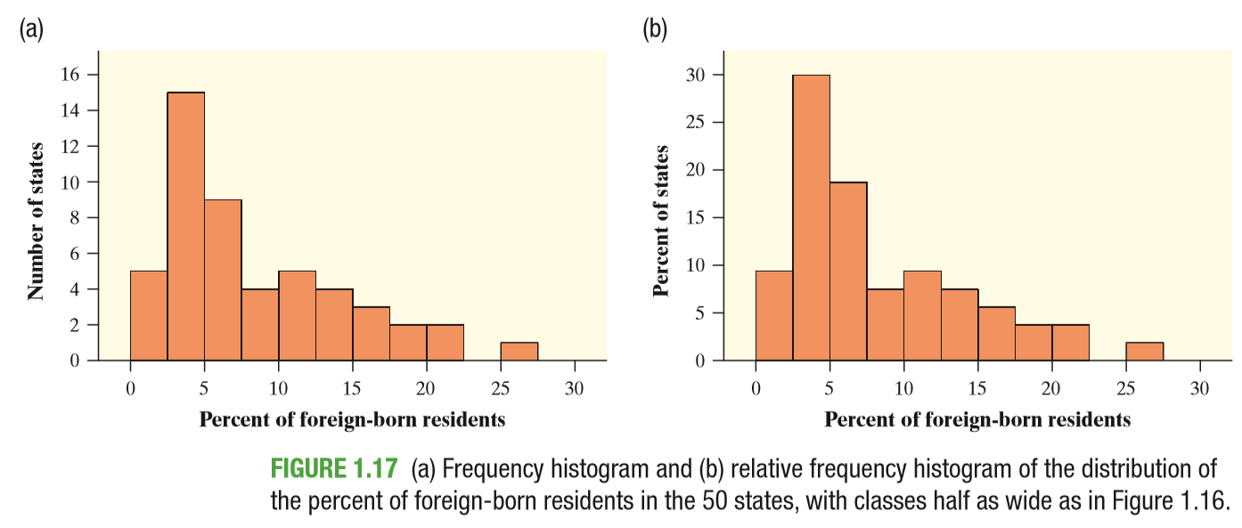
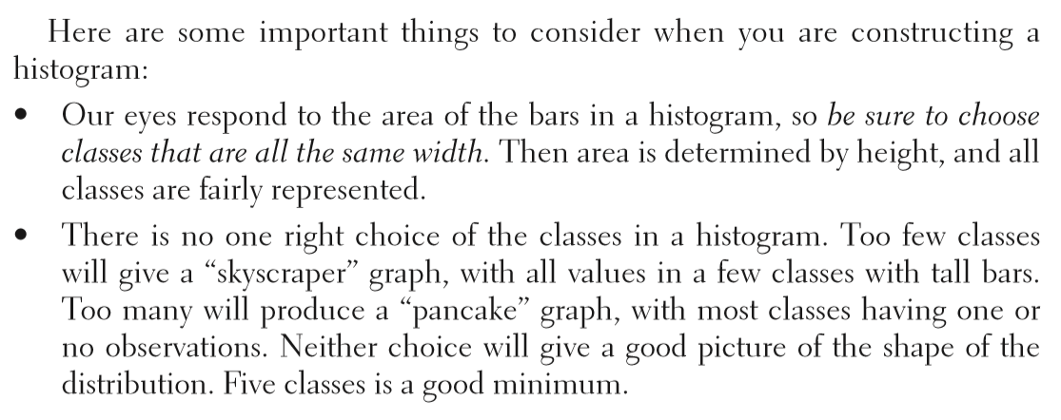

What are we actually doing when we make a histogram?
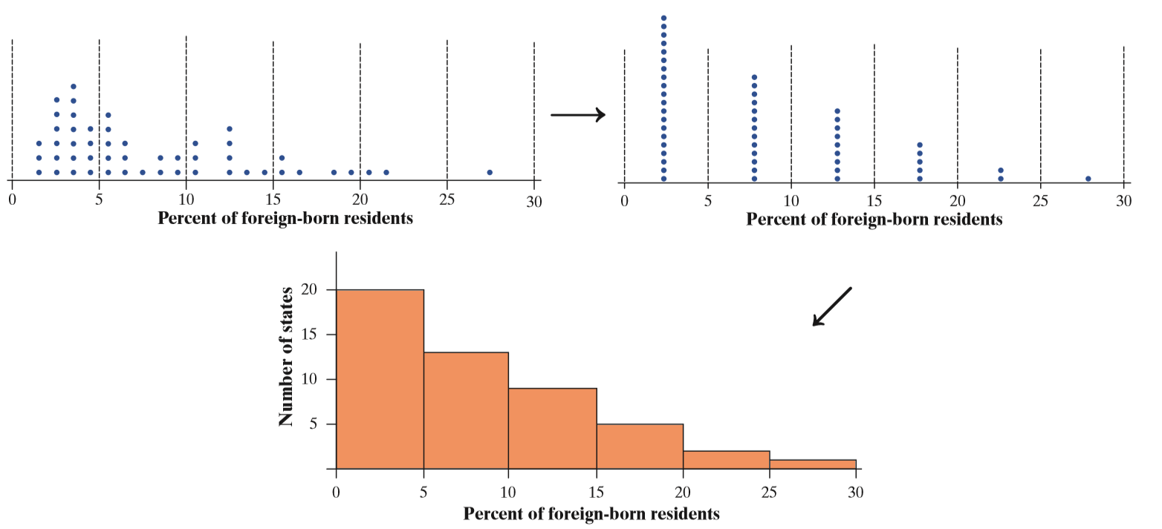

CALCULATOR HINTS TO MAKE A HISTOGRAM:
- Enter data for the percent of state residents born outside the US.
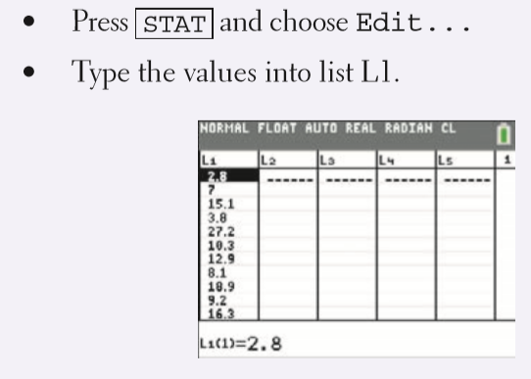
- Set up a histogram in the Statistics Plot menu.
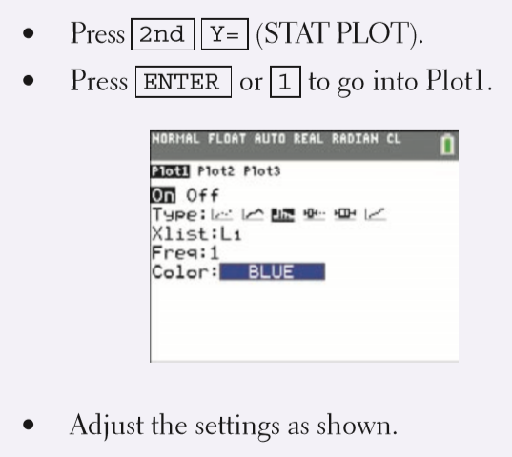
- Use ZoomStat to let the calculator choose classes and make a histogram.
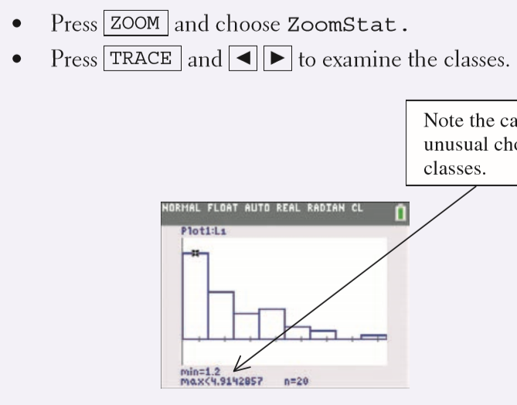
- Adjust the classes to match those in our histogram.
