AP Stats
Chapter 1 1.2 (day 1) Notes Outline

To display the distribution of a _______________________________ variable, use a ____________
________________________ or a _________________________________. In this section we will
learn how to display a ______________________________ variable.

One of the simplest graphs to construct and interpret is a ______________________________.

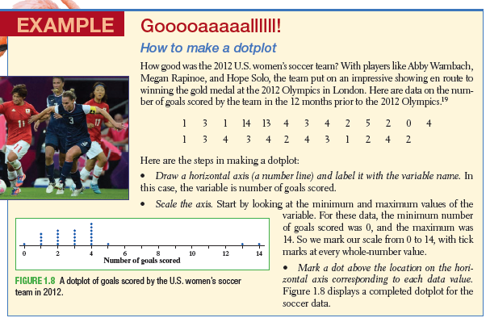
The purpose of a graph is to help us understand the data. After you make a graph, always ask
“What do I see?” This is when you need to CUSS and BS!!!!!

C

U

S

S

and

B

S
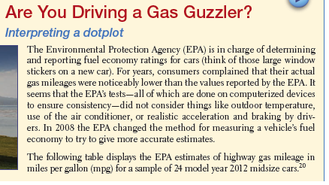
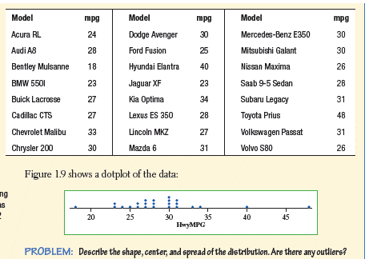

Describing Shape:
When you describe a distribution’s shape, concentrate on the main features. Look for rough symmetry or clear skewness.
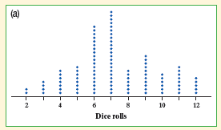
A distribution is roughly symmetric if the right and left sides of the graph are approximately mirror images of each other.

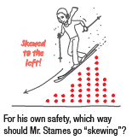
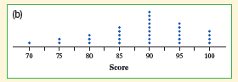
A distribution is skewed to the right if the right side of the graph (containing the half of the observations with larger values is much longer than the left side. It is skewed to the left if the left side of the graph is much longer than the right side.

