Determine the ratio of the areas, given the ratio of the sides of a polygon.
- 3/5

- 1/4

- 7/2

- 6/11

Determine the ratio of the sides of a polygon, given the ratio of the areas.
- 1/36

- 4/81

- 49/9

- 25/144

This is an equilateral triangle made up of 4 congruent equilateral triangles.
- What is the ratio of the areas of the large triangle to one of the small triangles? 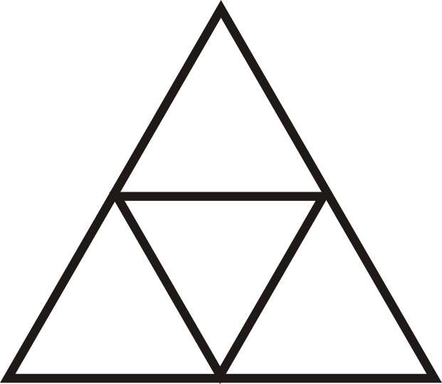

- What is the scale factor of large to small triangle?

- If the area of the large triangle is 20 units2, what is the area of a small triangle?

- If the length of the altitude of a small triangle is 23–√, find the perimeter of the large triangle.

- Find the perimeter of the large square and the blue square.

- Find the scale factor of the blue square and large square.

- Find the ratio of their perimeters.

- Find the area of the blue and large squares.

- Find the ratio of their areas.

- Find the length of the diagonals of the blue and large squares. Put them into a ratio. Which ratio is this the same as?

- Two rectangles are similar with a scale factor of 47. If the area of the larger rectangle is 294 in2, find the area of the smaller rectangle.

- Two triangles are similar with a scale factor of 13. If the area of the smaller triangle is 22 ft2, find the area of the larger triangle.

- The ratio of the areas of two similar squares is 1681. If the length of a side of the smaller square is 24 units, find the length of a side in the larger square.

- The ratio of the areas of two right triangles is 49. If the length of the hypotenuse of the larger triangle is 48 units, find the length of the smaller triangle’s hypotenuse.

Questions 23-26 build off of each other. You may assume the problems are connected.
- Two similar rhombi have areas of 72 units2 and 162 units2. Find the ratio of the areas.

- Find the scale factor.

- The diagonals in these rhombi are congruent. Find the length of the diagonals and the sides.

- What type of rhombi are these quadrilaterals?

