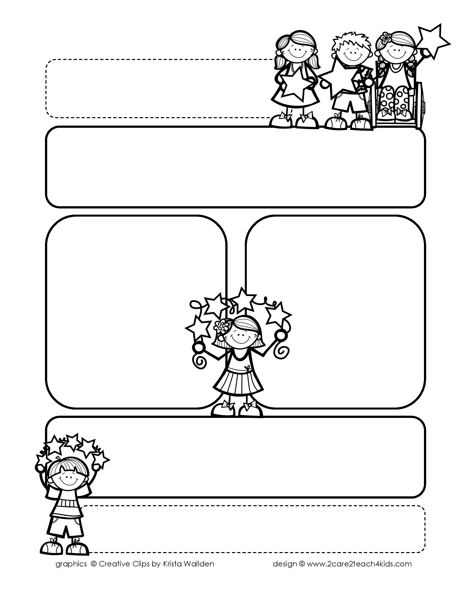

Peek of the Week-First Grade

September 23rd-27th, 2018

**Reading/Phonics/Writing**

Reading: building good reading habits, ABC order to the 1st letter Phonics: changing beginning/ending sounds to make & solve new words Writing: small moments- writing with focus, detail, & dialogue

**Math**

Addition & subtraction up to 10, Time to the Hour

**Science/Social Studies:**  Investigating Properties of objects/Exemplifying good citizenship.

**Reminders…**

* Check your child’s folder each day.
* Your child will need to turn in homework on Fridays.
* Home readers have started! Please have your child read

daily!

* Book Fair – Sept. 23-26th.

**Ask your child about:**

How does a good reader tackle a tricky word?”

**Words of the Week**

do, go, he, in, is