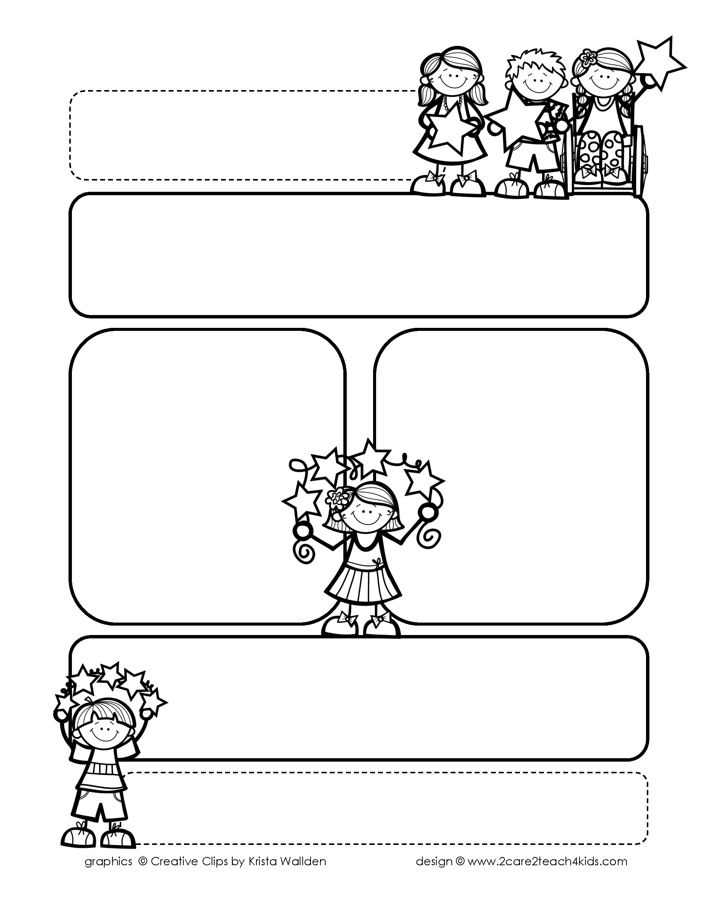

Peek of the Week-First Grade

October 1st-5th, 2018

**Reading/Phonics/Writing**

Reading: building good reading habits, word detectives for decoding Phonics: differences between uppercase and lowercase letters, consonant sounds Writing: small moments- writing with focus, detail, & dialogue, compound words

**Math**

Balanced equations, time to the hour

**Science/Social Studies:** Energy/ Exemplifying good citizenship

**Reminders…**

* 10/5 –Picture day
* 10/8 – Student Holiday
* 10/17 – 10/19 – Fall Break
* Homework due on Fridays
* Art teacher is requesting wipes for her classroom.

**Ask your child about:**

What does it mean to “try it two ways” when you come to a tricky word.

**Words of the Week**

Review all words