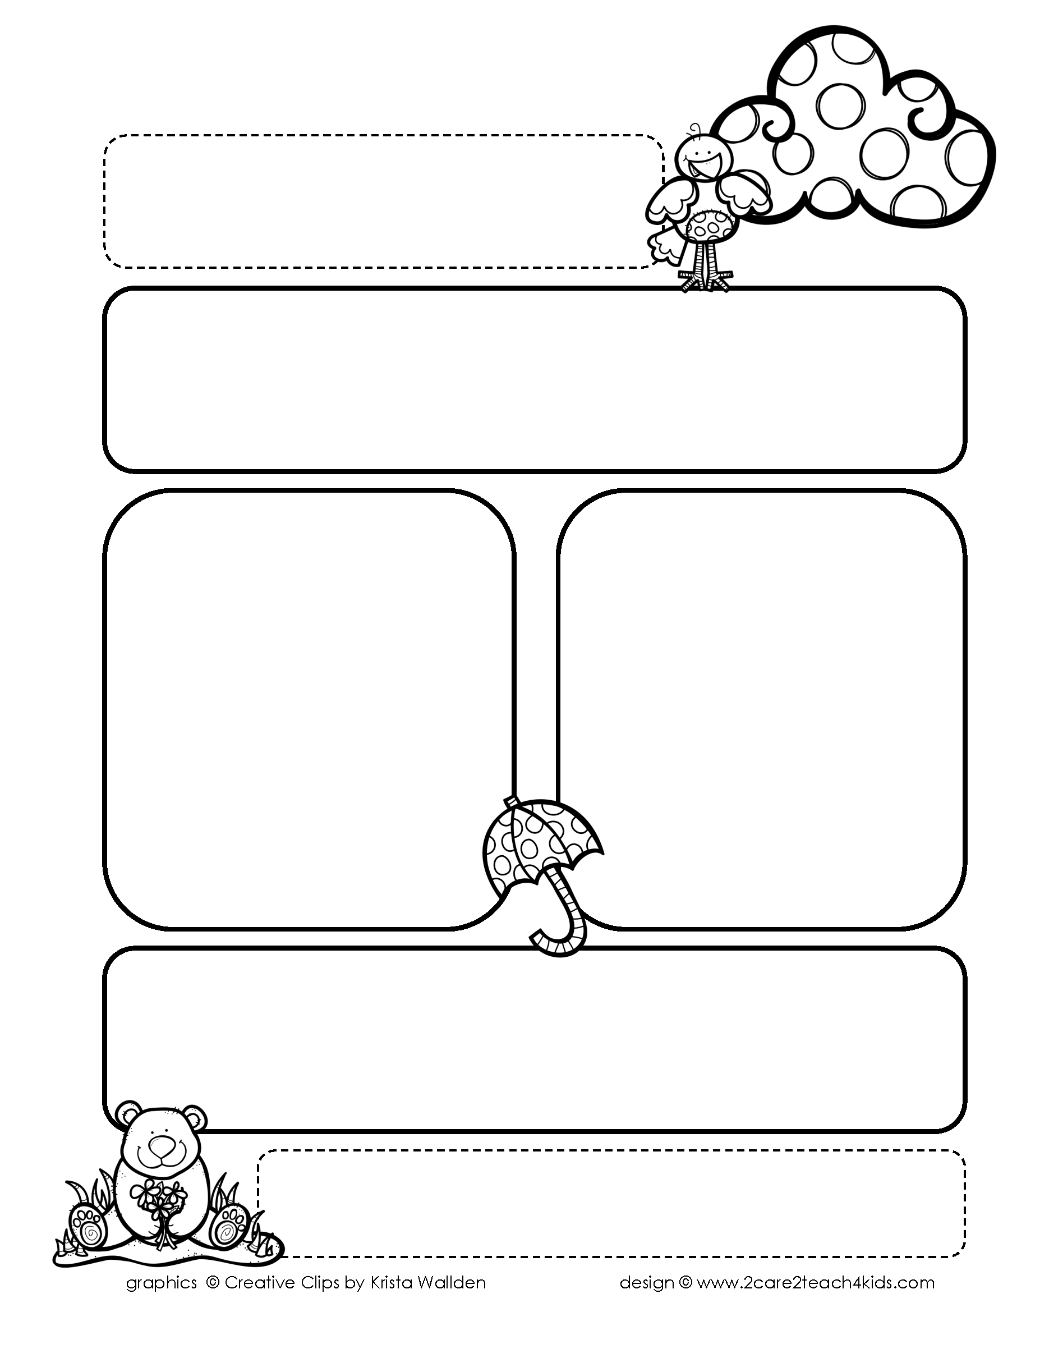

**Please feel free to contact anytime. Our office hours are as followed: Monday, Tuesday 10:00-12:00 Wednesday 4:00-6:00 Thursday 10:00-12:00, Friday- Holiday**

**Looking Back Week 2: (March 31-April 3)**

* **Reading**- Make a connection to a story.
* **Writing**-Share your final copy of the opinion letter piece.
* **Math-**Measure 1 of the three snakes you drew in inches
* **Math-**Measure your pet or draw a picture of a pet and measure it.
* **Science-** Draw a Food Chain and share
* **Science-** Share what you know about Food Chains

If you missed an assignment last week and the flipgrid video has been taken down; please send a picture of the assignments to the right to:

* **Math/Science/Social Studies-** [**melanie.hertenberger@sfisd.org**](mailto:melanie.hertenberger@sfisd.org)
* **Reading/Writing-** [**kimberly.wylie@sfisd.org**](mailto:kimberly.wylie@sfisd.org)
* **Name your email: Student’s Name/Day/Subject Example: John Smith Day 2 Math**

**Peek of the Week-Wylie/Hertenberger**

**April 6-9 (Week 3)**

**This Week Due (Week3):**

* **Reading Response-Thursday:** Respond to Writing Options After Reading Chart **(Refer to Wylie’s FlipGrid)**
* **Writing Response-Thursday:** Read your finish piece and use the checklist from the video.
* **Math Response- Tuesday:** Show the tower you built or drew and what it measures in cm.
* **Math Response –Thursday:** Tell me 3 objects you can measure in cm &measure in meters from the S’more page.
* **Science/Social Studies Response-Thursday:** Name the community you live in & 3 reasons how you know.

**Weekly Assignments Due- FlipGrids**

* **Reading/Writing Response- Thursday**
* **Math Response- Tuesday and Thursday**
* **Science/Social Studies Response- Thursday**