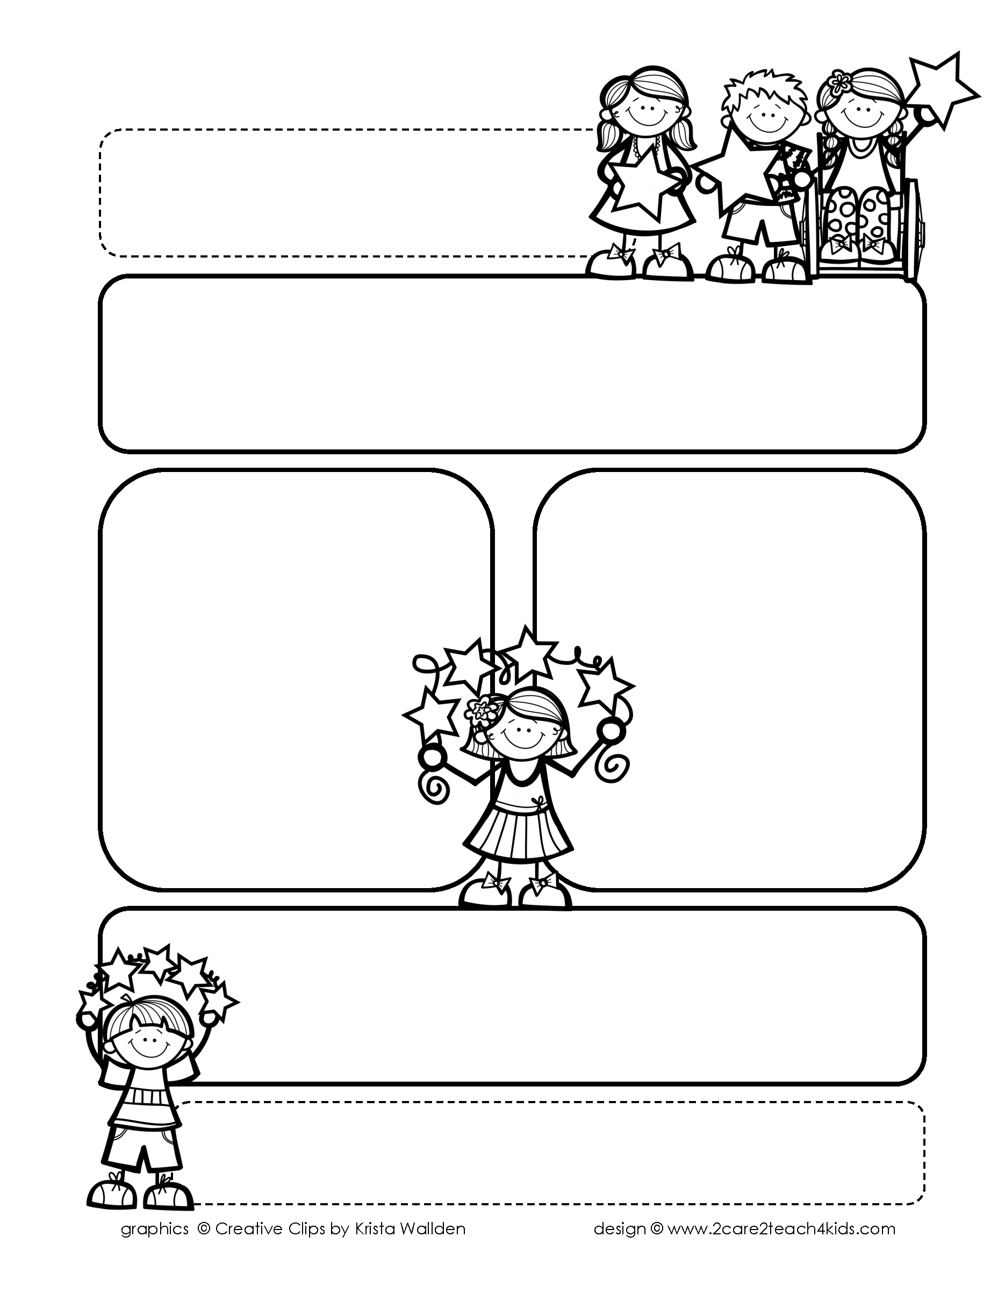

Peek of the Week-First Grade

May 6th – 10th, 2019

**Reading/Phonics/Writing**

Reading: readers get to know characters, the gift of reading Phonics: review 3rd nine weeks’ phonograms Writing: research a topic, write informational books

**Math**

Unit 15/16: 3D shapes, non-standard linear measurement

Word problems

**Science/Social Studies:** camping and bugs/making economic decisions, cinco de mayo, recycling

**Reminders…**

* May 11th ALL library books due!
* Monday, May 27th

NO SCHOOL (Memorial Day)

* Wednesday, June 5th

End of Year Party

11:30-12:30

* Thursday, June 6th

Last Day/Early Release/Report cards issued

**Spelling (**spelling tests are on Friday)

cage, game, dodge fetch,

write, place, crash, gnat,

know, knit

**Words of the Week**

Review all 4th nine

weeks sight words