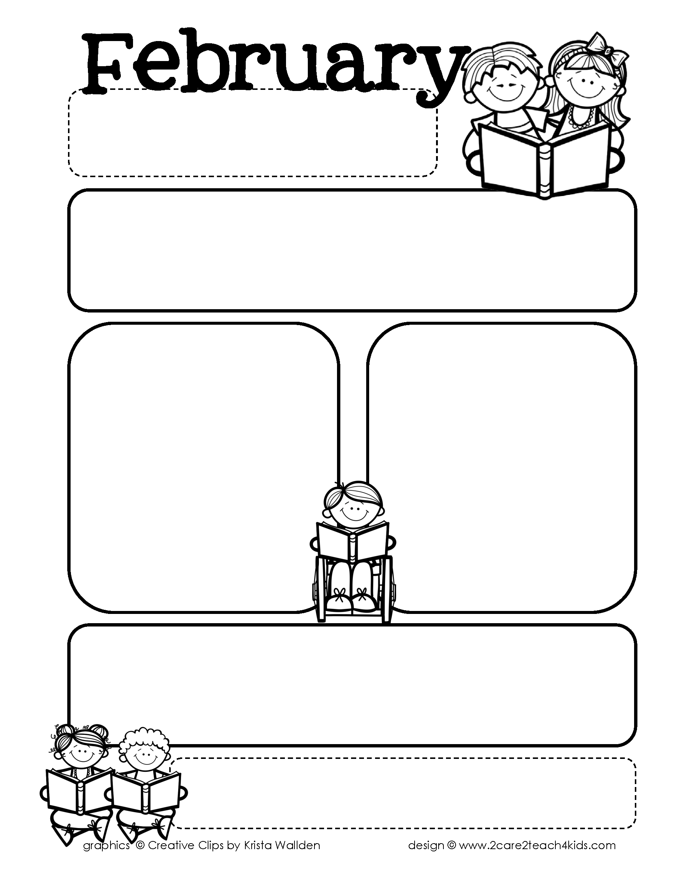

**Peek of the Week-Second Grade**

**February 26- March 2, 2018**

**Third Nine Weeks Sight Words- (these will be tested at the end of the nine weeks) about, better, bring, carry, clean, cut, done, draw, drink, eight, fall, far, full, got, grow, hold, hot, hurt, if, keep, kind, anything, bad, children, father, feet, fine, hope, horse, I’m, land, leave, money, morning, mother, night, pair, people, second, should, start, story, sun, table, third, told, turn, while, yard, and yesterday**

**\*Student can practice with flashcards or by writing these words in sentence**

**Math-** Reading and writing Time to the minutes and distinguishing between AM and PM

**Science-** Garden Habitats (Characteristics of a Plant)

**Social Studies-** Wants and Needs

**Tip of the Week:**

*Allow your child to hold the door open for someone as the enter a restaurant or store

**A Look Ahead…**

* 2/26-3/2 Texas Public School Week
* 2/27 100th day of school
* 3/1 Open House 5:30-7:00
* 3/8 Spring Pictures
* 3/12-16 Spring Break
* 3/28 2nd Grade Easter Feast and Party
* 3/30 Holiday

**Readers** formulate open ended questions about a topic. Students gather evidence and use text features to gather evidence.

**Writers** will gather resources and information on informational text and draft an informational piece.

**Spelling Pattern-** Prefixes in and dis

**Example:** disagree, disapprove, and informal