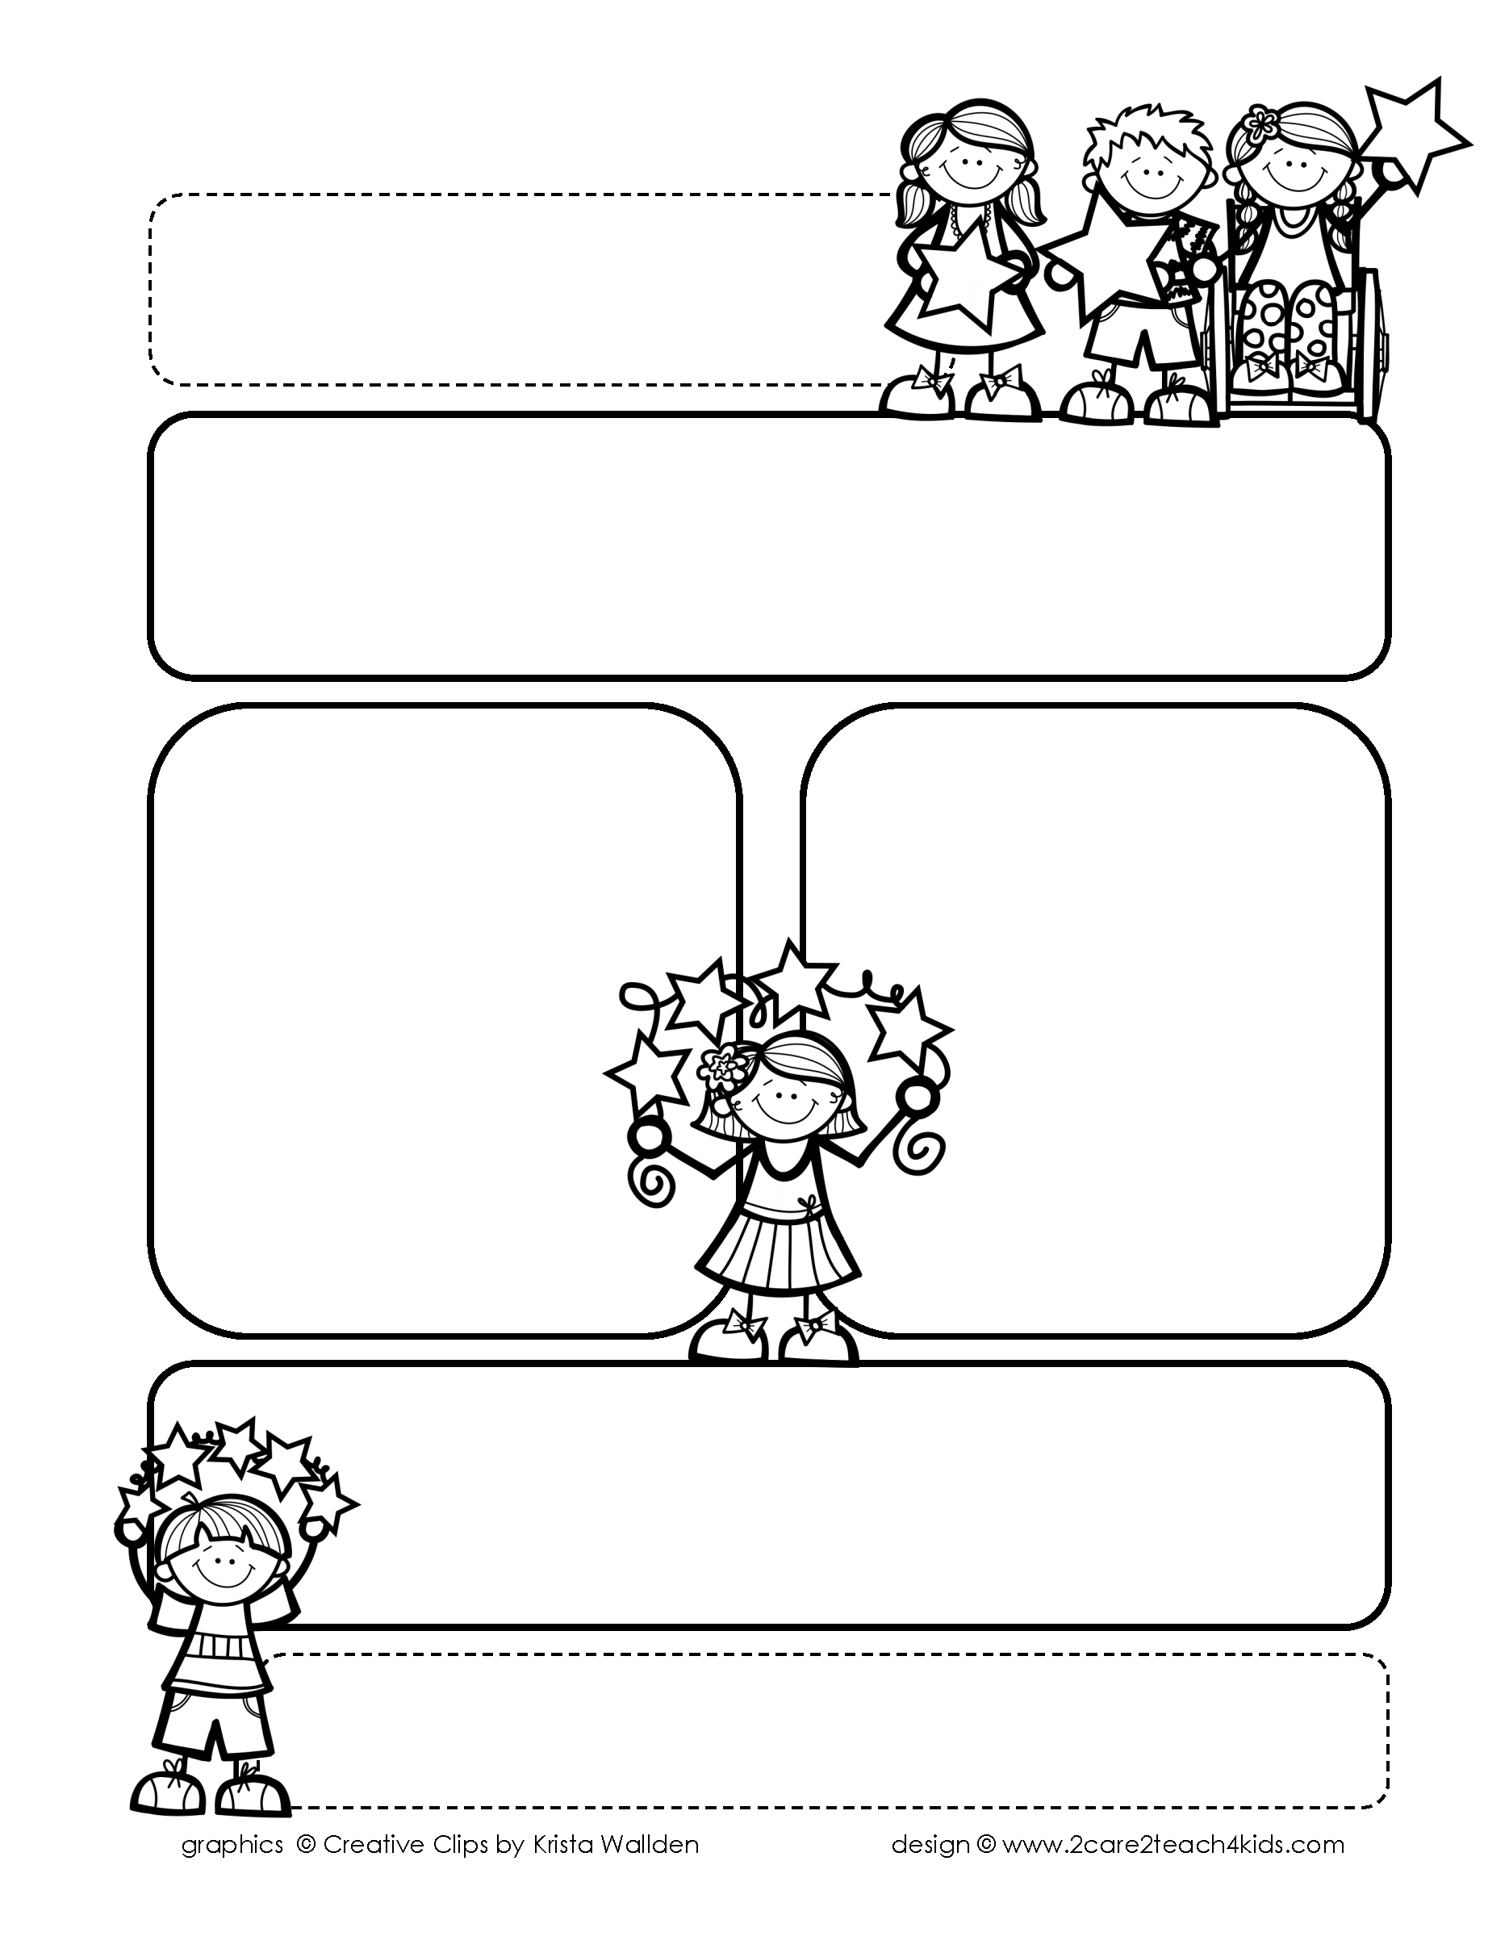

Peek of the Week-First Grade January 22nd-25th, 2018

**Reading/Phonics/Writing**

Reading: read to understand, re-read for meaning Phonics: long vs short vowel sounds, consonant digraphs Writing: 0pinion writing, persuasion, compare/contrast

**Math**

Unit 8: add multiples of 10 to a one digit number, ten more/less,

model and compare numbers to 120

Word problems

**Science/Social Studies:** food chains/inventors

**Reminders…**

* January 21st NO SCHOOL
* February 15th and 18th NO SCHOOL!
* March 11th-15th Spring Break

**Spelling (**spelling tests are on Friday)

slope, hope, joke, broke, smoke

rose, nose, chose, globe

robe

**Words of the Week**

so, you, too, will, two