NAME ____________________________________________________________________________________________________ CLASS PERIOD _____________
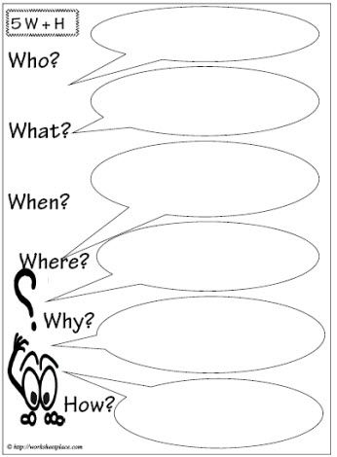
- What Is POP art?

- What are some of the characteristics of POP art?

- How did Andy Warhol change how art was made and appreciated?

- Is it right for Andy Warhol to take credit for all of the work done in his “Factory?” Why or why not?

